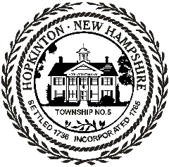
Town of Hopkinton Office of Select Board

330 Main Street, Hopkinton NH 03229-2627 - (603) 746-3170 – www.hopkinton-nh.gov

SELECT BOARD
PUBLIC MEETING AGENDA
MONDAY, AUGUST 2, 2021 – 5:30 PM
HOPKINTON TOWN HALL

I. CALL TO ORDER

II. POINTS OF PRIDE

III. ADMINISTRATION
i. Approval of Consent Agenda
ii. Approval of Public Meeting Minutes of July 19, 2021
iii. Approval of Public Meeting Minutes of July 27, 2021
iv. Approval of Non Public Meeting Minutes of July 19, 2021, Session I
v. Approval of Non Public Meeting Minutes of July 19, 2021, Session II
vi. Approval of Non Public Meeting Minutes of July 19, 2021, Session III

IV. PUBLIC APPOINTMENTS

V. OLD BUSINESS

VI. NEW BUSINESS

VII. TOWN ADMINISTRATOR UPDATES

VIII. PUBLIC FORUM

IX. OTHER

X. NON PUBLIC SESSION

XI. ADJOURNMENT

